**DAILY ONLINE ACTIVITIES SUMMARY**

|  |  |  |  |  |  |  |  |  |
| --- | --- | --- | --- | --- | --- | --- | --- | --- |
| **Date:** | **30/05/2020** | | | | | **Name:** | **V ANJANA PAI** | |
| **Sem & Sec** | **IV sem & B section** | | | | | **USN:** | **4AL18CS094** | |
| **Online Test Summary** | | | | | | | | |
| **Subject** | | **1)DATA COMMUNICATION**  **2)COMPLEX ANALYSIS, PROBABILITY AND STATISTICAL METHOD** | | | | | | |
| **Max. Marks** | | **1)30**  **2)30** | | **Score** | | | **1)26**  **2)22** | |
| **Certification Course Summary** | | | | | | | | |
| **Course** | **Introduction to Digital Marketing** | | | | | | | |
| **Certificate Provider** | | | **Greatlearning academy** | | **Duration** | | | **2.5 hours** |
| **Coding Challenges** | | | | | | | | |
| **Problem Statement1:** Write a C Program to count Uppercase, Lowercase, special character and numeric values for a given String. | | | | | | | | |
| **Status: Executed** | | | | | | | | |
| **Uploaded the report in Github** | | | | | **YES** | | | |
| **If yes Repository name** | | | | | **lockdown-coding** | | | |
| **Uploaded the report in slack** | | | | | **YES** | | | |

Online Test Summary: 18CS46 test was scheduled from 9:15am t0 10:00am. The portion for the IA was 3rd and 4th module there were 30 questions and the time assigned was 45 minutes the questions were mcq type.

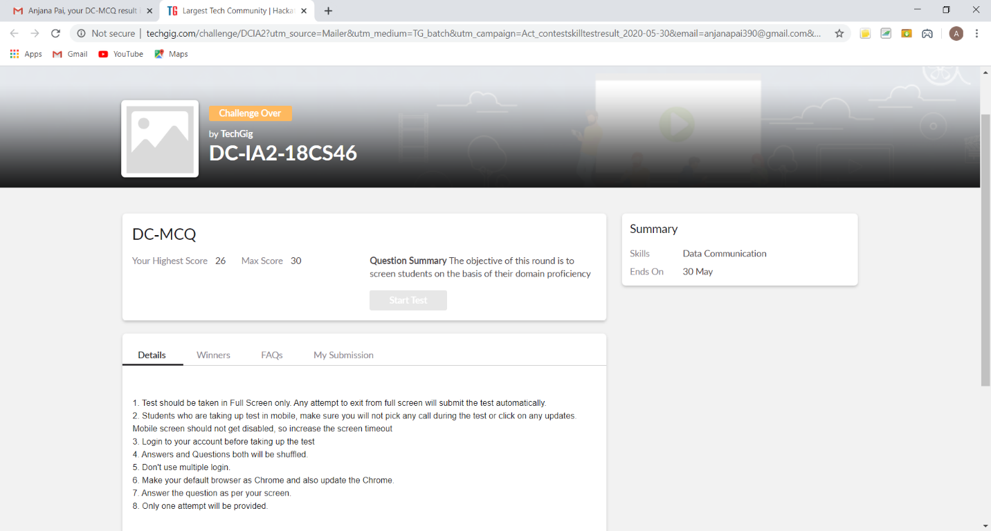

This is the snap shot of completion of test and the marks obtained in 18CS46.

18MAT41 test was scheduled from 2:55pm t0 3:40pm. The portion for the IA was 3rd module there were 20 questions (10Q for 1m & 10Q for 2m) and the time assigned was 40 minutes the questions were mcq type.

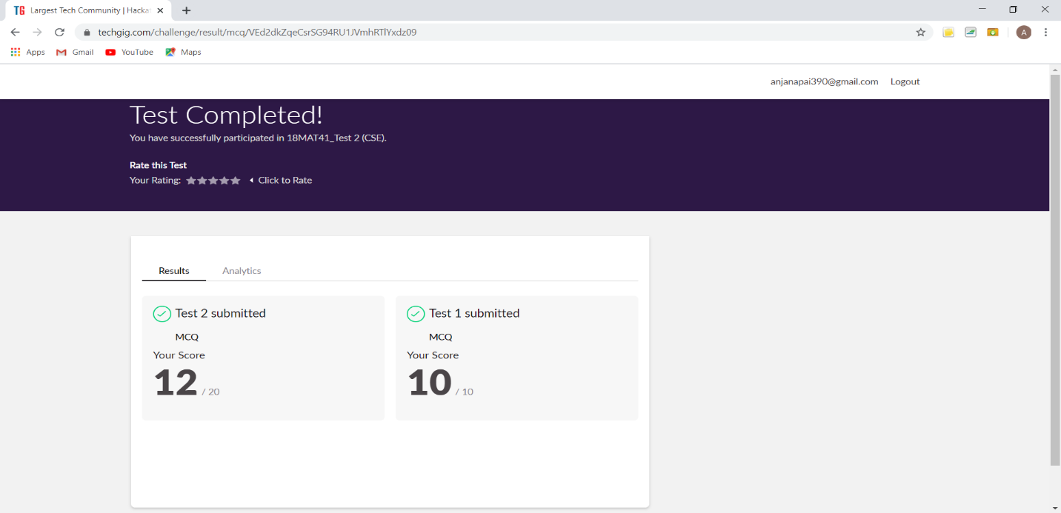

This is the snap shot of completion of test and the marks obtained in 18MAT41.

Online Certification Course Summary: Today I continued with the Digital Marketing course. where I learnt about Facebook Interface and Types of Audiences and also Purpose of Using Facebook as Marketing Channel.



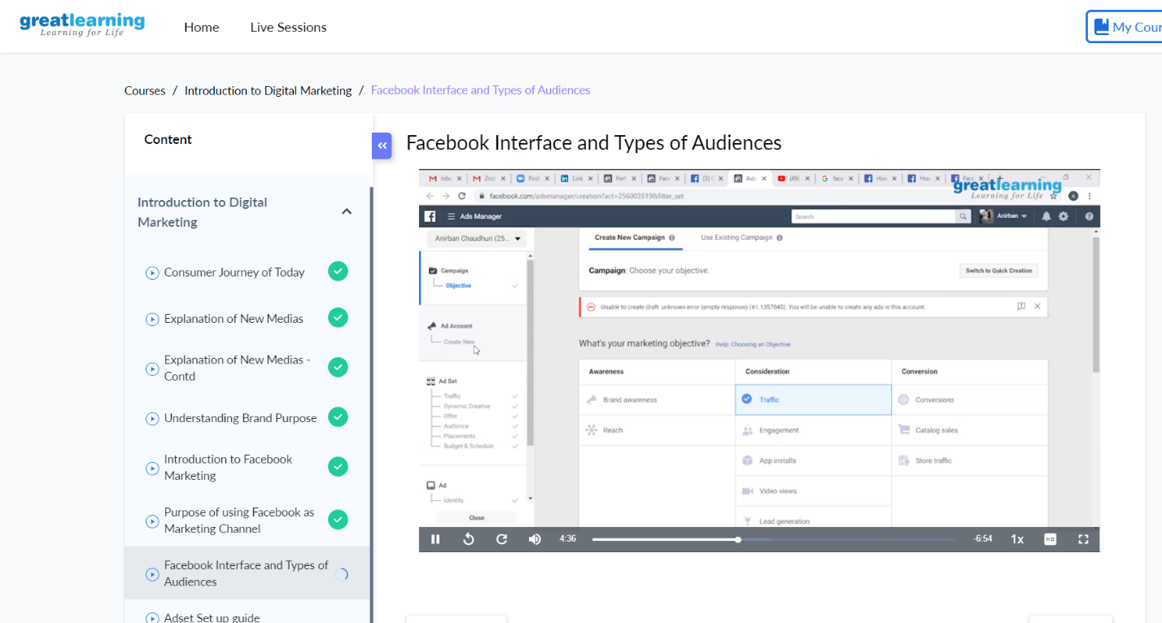

These are the Snap shots of today’s sessions.

Online Coding Summary: **Today I had received one program from prof. Shilpa CSE Dept. The program is mentioned above in the coding challenges(pg.01). I have also uploaded it to my Github repository.**

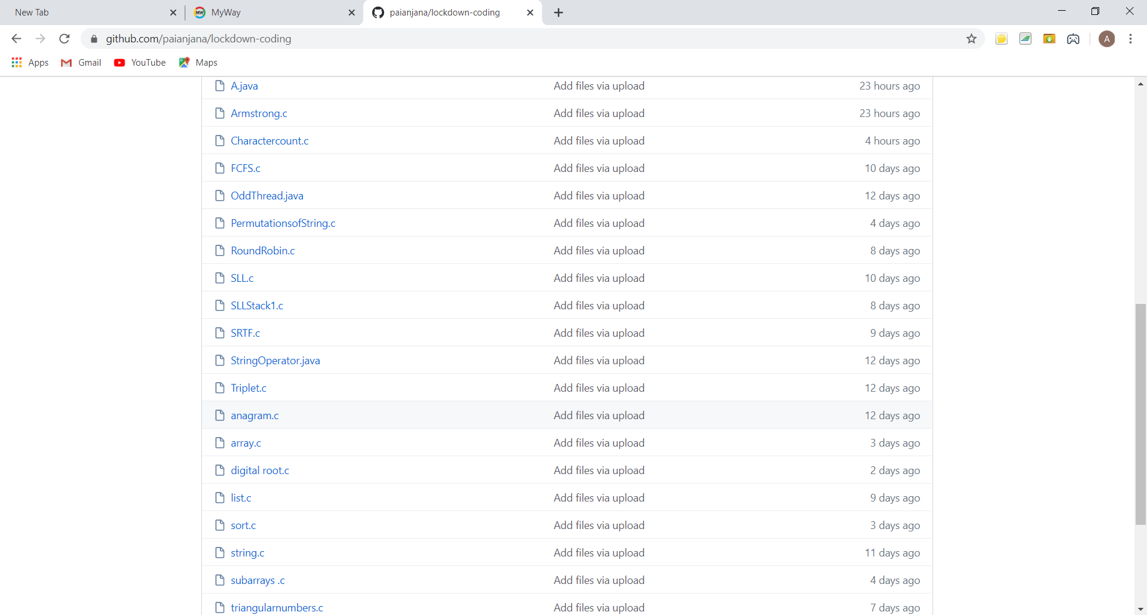

**This is the snap shot of my GitHub repository** where I have uploaded the code. File name is Charactercount.c